

BRAC UNIVERSITY

CSE461: Introduction to Robotics

Lab Project Report
Title: SmartSort: AI-Based Automatic Waste Segregation Robot
by
Group 3
Section 4
Group Members:
Name | ID
M. Aliul Siddique Antor | 21301633
Mihir Das | 22299480
Fariaa Afroz Esha | 22201530
Farhan Zarif | 23301692
Hirok Roy Rahul | 22299082
Department of Computer Science and Engineering
BRAC University
August 29, 2026

Abstract
SmartSort is an autonomous waste segregation robot that is small, compact and self-contained, and is suitable for segregation at source level between biodegradable waste and non-biodegradable waste. The system is composed of ESP32-CAM for image capture and CNN classification on board, and Arduino Uno for sensor reading and controlling actuators. An item detected is captured in a controlled environment, classified locally and delivered to the appropriate pile or compartment by means of a servo-controlled arm and gripper. Fill level is monitored by ultrasonic sensing and Buzzer and LED alert states are for full-bin or uncertain-classification. The project fills the gap of the lack of source segregation in Dhaka and presents how embedded machine learning, microcontroller interfacing and robotic actuation can help achieve a meaningful and viable sustainable goal.

Keywords
Embedded systems; waste segregation; ESP32-CAM; Arduino Uno; computer vision; robotic arm; sustainability

1. Introduction
Organic and inorganic materials at source make it more difficult to recycle and/or compost municipal solid waste. According to the project proposal Dhaka generates about 6,500 tonnes of MSW per day of which about 70-80% is organic. However, in homes, dormitories, university corridors and in small offices, it is not always ensured that sources are properly segregated, and therefore, recoverable material is sometimes mixed with other materials that are sent to landfill.
SmartSort is intended to create and test an autonomous robot that: Identifies a waste item, captures its image, classifies the waste as biodegradable or not, and physically sorts the waste without remote control. The system is built for a controlled demonstration setup that allows the usage of one light weight at a time, a stable light source setup, a fixed camera position and pre-defined arm poses.
The project is relevant to Computer Interfacing because the required input components are sensors, the embedded image processing, UART communication between ESP32-CAM and Arduino Uno, PWM-based servo, regulated power supply and feedback is given by the buzzer and LED modules.

2. Related Work/ Inspiration
Some current smart-bin technologies use proximity sensors to trigger a lid opening or ultrasonic sensors to measure fill level. For a small course prototype, industrial waste-sorting systems might be employed using conveyors, larger cameras and external processing, but these are not cost-effective and would not work well for a small prototype. SmartSort is based on those systems but is built for a small, local, inexpensive system.
The key aspect of this project is the complete perception-decision-actuation loop. The ESP32-CAM does the classification of the images locally, the Arduino Uno is in charge of controlling the sensors and servos, and the arm and the gripper are responsible for the classification itself. Instructor feedback also influenced the final direction, focusing on a repeatable pick-and-place demonstration – two object classes, simple lightweight objects, predetermined arm positions, and full-bin or error notification behavior.

3. Technical Approach
The four major layers of the system are: Sensing, Classification, Control, and Actuation. In the IR sensing stage, the presence of the item is detected, followed by an image taken by ESP32-CAM and the CNN model is then processed, and the classification result is sent to Arduino Uno with the corresponding confidence value. The Arduino then controls the servo motors of the arm, the joint, and the gripper, and ultrasonic sensors monitor the fill level of the bins, and the buzzer/LED module signals full-bin and uncertain-classification situations. The workflow is: Detection of the item, taking pictures of the item, image classification, sorting pose selection, picking up the item, and placing the item or signaling the fill level.
Components: ESP32-CAM module, Arduino Uno R3, servo motors (for arm and gripper), HC-SR04 ultrasonic sensor, IR proximity sensor or IR array, buzzer module, LED module, regulated 5 V power supply, jumper wires, breadboard, and a plywood or acrylic chassis. Arduino IDE is included for programming the controller and Edge Impulse and TensorFlow Lite Micro to train and deploy the tiny image-classification model.

Component | Unit Cost (Tk.) | Quantity | Total (Tk.)
ESP32-CAM module | 940 | 1 | 940
Arduino Uno R3 | 939 | 1 | 939
MG90S / micro servo motors | 180 | 2 | 360
Ultrasonic sensor (HC-SR04) | 125 | 2 | 250
IR proximity sensor / IR array | 70 | 1 | 70
5 V exhaust fan or auxiliary airflow module | 150 | 1 | 150
White LED ring or strip | 60 | 1 | 60
Buzzer and LED module | 30 | 1 | 30
18650 battery pack and charging module | 300 | 1 | 300
5 V / 2 A buck converter | 120 | 1 | 120
Acrylic/plywood chassis and compartments | 1,200 | 1 | 1,200
Jumper wires and breadboard | 350 | 1 | 350
Miscellaneous screws, glue, wiring, resistors, capacitors | 700 | 1 | 700
Estimated Total |  |  | 5,469
Estimated Total Cost: Tk. Based on the components included in the proposal, this is 5,469. The main components that contribute to the cost are the chassis and bin compartments, ESP32-CAM, Arduino Uno, and other wiring and mounting.
Circuit/Schematic: The circuit shows the wiring connections between the ESP32-CAM, Arduino Uno, ultrasonic sensors, IR sensing array, servo motors, and regulated 5 V power supply, all connected together with a common ground. The servo signal lines are connected to the Arduino PWM pins and the classification results are sent to the Arduino from the ESP32-CAM. Stable power is needed since there can be abrupt demand for power due to the capturing action and servos movement of the camera.
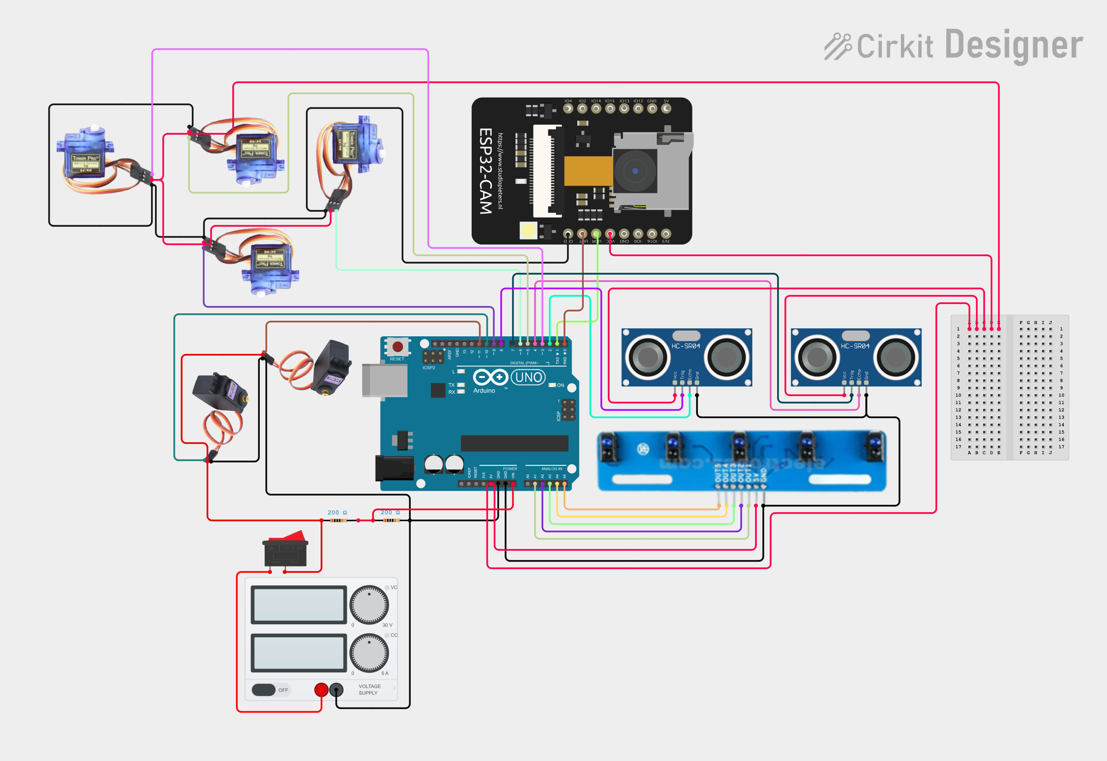
Figure 1. SmartSort control circuit schematic.
Functionality: When the robot is in operation it awaits an item, it takes a controlled photo of that item, it classifies the item on board and sends the label to the Arduino. When the result is accepted, the arm will move to the pick-up position, close the gripper, go to the selected biodegradable or non-biodegradable section, open the gripper and return to the position where it started. When a classifier is not certain, the system can warn the user, instead of simply putting the item in the wrong pile. The ultrasonic sensors will periodically make an estimation of the fill level of the bin or pile, and will activate a buzzer/LED output if the fill level reaches the level set.
Challenges: There are a number of potential risks including ESP32-CAM brownout during capture, servo stall or object slip during pick up, inconsistent classification due to lighting changes, ultrasonic noise within the narrow bins and communication logic level differences between the Arduino and the ESP32. They are addressed by a regulated 5 V supply, common grounding, fixed lighting and background, pre-defined lightweight test objects, median filtering for distance readings and UART wiring based on a level.

4. Sustainability & Impact
Sustainability: SmartSort helps to make separation of waste before the biodegradable and recyclable items are contaminated, which contributes to environmental sustainability. It is low voltage electronics design and only requires energy when sorting, so the energy is not significant. Consider using plywood or acrylic for the chassis and individual parts of the electronics can be repaired, reused or replaced without discarding the entire system.
Advantage: The project will support households, dormitory buildings, campuses and small offices to reduce the manual handling of the waste and encourage source separation. It also demonstrates to students and users how robotics can be directly applied to a community sustainability problem as opposed to just a classroom demonstration.
Future work: Extending the set of images, further strengthening of arm, adding a dashboard for the classification and fill level data, and adding a more reliable dump/clearing mechanism once the pick and place sequence is consistent.
Limitations: Only a single light object can be used at present in the prototype. Needs an experienced item set, controlled lighting, set camera position and reproducible object shapes. Not yet suitable for outdoors and industrial waste conditions when it is wet and heavy.

5. Results & Discussion
The project materials available do not contain an extensive experimental log, but design targets and demonstration feedback. The system should be tested with repeated tests with test items for final testing. Classification accuracy, correct physical routing, cycle time, fill level alert accuracy, pickup reliability and power stability are the most critical measurements.
The proposed targets are: 85% accuracy in binary classification, 95% routing accuracy at confidence level above 0.80, 5 seconds or less per fill level alert and accuracy within +/-2cm in fill level alerts. The feedback suggests a harder final demonstration goal to shoot for of 95% or greater on the accuracy of the classifiers due to controlled item set and environment. It also suggests simplifying the physical task: two colors for objects, one shape, and items that are not heavy are sufficient, with the pickup and autonomous sequence being repeatable.
There are, of course, design compromises, such as the one between recognition breadth and mechanical reliability. However, a wide open class would make the project sound more general, but make the final demonstration more difficult to prove. The robotics task is better illustrated in a narrowed-down demonstration, using controlled lighting, two classes, and pre-determined arm poses, the robot detects, decides, moves, alerts and resets from a distance without a remote.

6. Conclusion
SmartSort is an autonomous Waste Segregation system based on a low cost self-learning technique, integrating sensing, embedded image classification, actuator controls and user feedback. The ESP32-CAM delivers the perception layer, the Arduino Uno acts as the sensor/servo driven actuation controller, and the robotic arm executes the visible sorting function. The design works best in a controlled source level environment, where the number of light objects and pick and place poses is limited.
The project is important as it connects robotics practice with a real-world sustainability challenge. SmartSort can help reduce the risk of handling contamination, increase valuable material recovery, and demonstrate the value of computer interfacing in building an environmental tool.

7. Contribution
Name | ID | Role(s) / Responsibilities | Specific Contributions

References
Arduino. (n.d.). Arduino Uno Rev3 documentation. https://docs.arduino.cc/hardware/uno-rev3
BRAC University. (2026). CSE461 lab project poster guidelines. Course material.
Edge Impulse. (n.d.). Edge Impulse documentation. https://docs.edgeimpulse.com/
Group 3. (2026). SmartSort: AI-based automatic waste segregation robot project proposal. CSE461: Introduction to Robotics, BRAC University.
Google. (n.d.). TensorFlow Lite for Microcontrollers. https://www.tensorflow.org/lite/microcontrollers

